ENVIRONMENTAL MONITORING USING IOT

SUBMITTED BY

NAME: S. Navin Raj Kumar

NM ID: au411521106037

PROJECT: ENVIRONMENTAL MONITORING

PHASE – 1 SUBMISSION DOCUMENT

* 

INTRODUCTION

* Environmental monitoring is a tool to assess environmental conditions and trends, support policy development and its implementation, and develop information for reporting to national policymakers, international forums and the public.
* Environmental monitoring is used in the preparation of [environmental impact assessments](https://en.wikipedia.org/wiki/Environmental_impact_assessment), as well as in many circumstances in which human activities carry a risk of harmful effects on the [natural environment](https://en.wikipedia.org/wiki/Natural_environment).
* All monitoring strategies and programs have reasons and justifications which are often designed to establish the current status of an environment or to establish trends in environmental parameters.
* Environmental monitoring products and environmental monitoring software, such as Environmental Data Management Systems (EDMS), facilitate the implementation and monitoring of environmental monitoring and assessment programs, which includes a central data management hub, automated environmental monitoring alerts, compliance checking, validation, quality control, and generation of reports on dataset comparisons.
* As human population, industrial activities, and energy consumption continues to grow, the continued development of advanced, automated monitoring applications and devices is crucial for enhancing the accuracy of environment.
* Environmental monitoring solutions have evolved over the years into Smart Environmental Monitoring (SEM) systems that now incorporate modern sensors, Machine Learning IOT devices.

IMPORTANCE OF ENVIRONMENTAL MONITORING

* The main objective of environmental monitoring is to manage and minimize the impact an organization's activities have on an environment, either to ensure compliance with laws and regulations.

BLOCK DIAGRAM OF ENVIRONMENTAL MONITORING

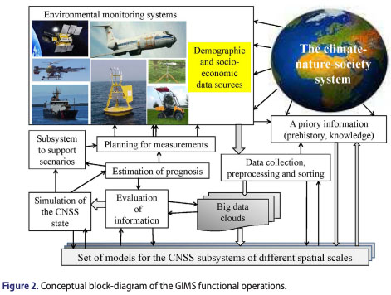

WAYS TO REDUCE THE ENVIRONMENTAL IMPACT

* Stop using plastic bags
* Skip the disposal items
* Go paperless
* Know what to recycle
* Reduce electronic usage
* Drive less
* Adopt water saving objects
* Leave only footprints behind

BENEFITS OF ENVIRONMENTAL MONITORING

* The purpose of an Environmental Monitoring Program is to identify problem areas where potentially harmful microorganisms may be harboring, becoming a source of contamination; as well as verifying the effectiveness of sanitation programs.

ADVANTAGES OF ENVIRONMENTAL MONITORING

* The primary benefit of environmental monitoring is to check that your policy statement, plan, or condition on a resource consent has resulted in the environmental outcome you expected. It provides information to understand the current state of the environment and assess whether things are getting better or worse.

CONCLUSION

* The Comprehensive Everglades Restoration Plan (Restoration Plan) Monitoring and Assessment Plan (MAP) is grounded in current scientific theory and practice of adaptive management. The least developed aspects of the planned adaptive management are feedback mechanisms to connect monitoring to planning and management.
* Restoration goals, objectives, and targets for the Everglades are inadequately defined and are not reconciled with the large-scale forces of change in south Florida.